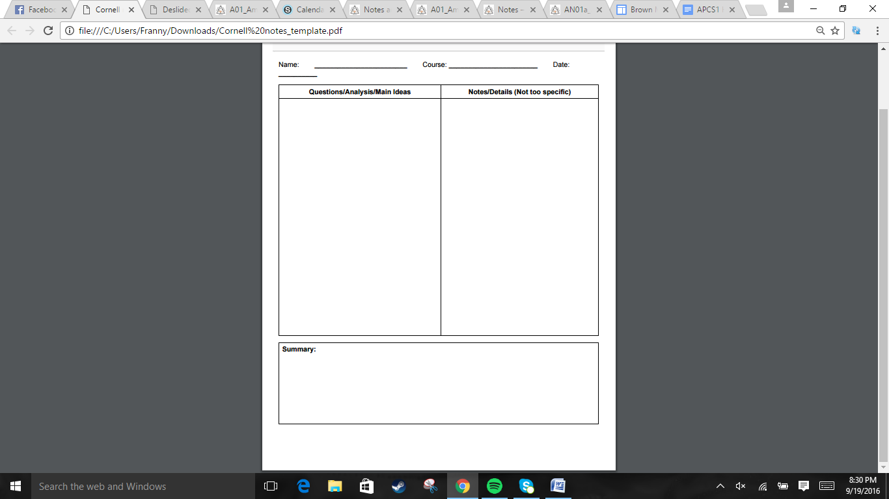  
  
  
  
  
  
  
  
  
  
  
  
  
  
  
  
  
  
  
  
  
  
  
  
  
  
  
  
  
  
  
  
  
  
  
  
  
  
  
  
  


.Cortes learned of the rich Mexica/ Aztec, empire => took a small force of men and convinced the Nahua to join in =>went to capital of Tenochtitlan => claimed they had disease that needed gold => Montezuma gave gold because he though Cortes was a god => Aztec rebel in spring of 1520 because of being forced to mine => Drove Cortes out => natives could not stand disease => Cortes counterattacks in 1521 => planned New Spain/Mexico City  
.Spanish settlers in Americas were men (Peninsulares), who married natives to create a large mestizo populatio, Spanish enforced the ecomienda =>1542, the system was abolished.  
.1513, Leon discovers Florida, Spanish try to conquer, but fail and gave up in 1562. Months later, French arrive, Spain ordered Aviles to drive them out by 1565 =>St.Augstine outpost  
.1540, Vasquez de Coronado led Spanish expedition to central USA, etc, but wasn't successful. As the Natives decreased, the Spanish priests gathered the remaining into congreaciones. In the winter of 1609-1619, Pedro de Peralta, governor of New Mexico, built Santa Fe.  
.Spanish priests & soldiers did not respect sacred objects. Natives were also forced to work and pay tribute  
. Popé led a rebellion in 1690, Natives gained controlled for 14 years.   
.Spanish had trouble regaining control because 1588, Spaish Armada defeated

The Spanish lead a lot of expeditions into the Americas, the most successful being conquering the Aztecs. Inland North American expeditions were less successful, but colonies were established. There was some rebellion from Natives, but they were stopped. The Spanish lost their edge when their armada was defeated by the English.

Jonathan Quang US History 9/22/2016

Section 1: Spain's Empire in the Americas  
How did the Spanish claim their empire in the Americas?  
  
  
  
  
  
  
  
  
  
What happened in North America?  
  
  
  
  
  
  
  
  
How well was Spain resisted?

.Colonies were funded by joint-stock companies => 1606, King James I granted Virginia company a charter => April 1607, reached Virginia, named settlement Jamestown  
.Colonists faced diseased water, hunger; colonists refused to do labor => Colonists decreased, Smith convinced Powhatan people to provide food =>He left because he got burned => more colonists arrived => Powhatan attack food sources => famine  
.New leadership punished those who don't work and brought cash crop: tobacco. 1612, Rofle crossbreeds weed + tobacco => lots of tobacco sent to England => more labor needed, headright system (come and get land), also used indentured servants, first African workers were indentured servants.  
. English did not forget Powhatan hostility, demanded tribute. One kidnapped child of the Chief Powhatan's daughter married Rolfe in 1614 => some peace. =>Powhata lose patience and raid => Virginia company loses lots of money => King revokes charter, declares royal colony => more troops  
.Poor people live on outskirts => money goes to corrupt plantation owners => poor people get angry that they are not getting protection from Natives => Berkley refused to offer aid => Nataniel Bacon raised an army in 1676 to fight Natives => army declared illegal => Bacon marched to James Town, violent => March fails, but message lives

Section 2: An English Settlement at Jamestown  
What struggles did English colonies have?  
  
  
  
  
  
  
  
  
  
  
  
  
What kind of conflict arose from settlers and Native Americans?  
  
  
  
How did economic differences split Virginia?

Jonathan Quang US History 9/22/2016

The English faced numerous troubles colonizing Jamestown, but they eventually got over it. Tobacco made the colony rich. The English and the Native Powhatan continue to have conflicts with each other, and Jamestown ends up being a royal colony. Some time later, economic differences led to Bacon's rebellion



.Puritans emigrated to create a model society with Jon Withrop being the first governor. Puritans originated from people dissatisfied with the Anglican church's traces of Roman Catholicism. A subset of those formed independent groups=> Separatists / Pilgrams => 1620, Plymouth colony  
.1629 - Withrop obtains royal charter for Massachusetts Bay company =>transfer HQ and charter to New England to be independent => 1930, Massachusetts Bay Colony established =>Plymouth incorporated  
.Adult males of Puritan church could vote. Emphasized productivity and obedience.  
.Roger Williams - wanted the charter to be revised to include Native Americans and no forced religion => kicked out by General Court => Founds Providence (capital of Rhode Island)  
. Anne Hutchinson was banished for believing that the church and its ministers were not needed to interpret the Bible => 1638 banished, went to Rhode Island =>1642, went to New Netherland (New York)  
. Native Americans needed more land than farmers, traded temporary land ownership for goods, but Europeans saw it as permanent => Connecticut 1637, Pequot VS Narragansett + colonists => Native Americans forced to work for English to live => Wampanoag Metacom (King Phillip) Warred against Puritans in 1675 using hit and run tactics => loses, Native Americans move out,

Section 3: Puritan New England  
How did Puritans end up making New England?  
  
  
  
  
  
  
  
  
What went wrong in the colony?  
  
  
  
  
  
  
How did Native Americans resist colonial expansion?

Jonathan Quang US History 9/22/2016

Puritans pursue their religious beliefs by setting up the colony, New England. The colony was successful, but some people were dissatisfied with the conservative nature of the Puritans. Eventually, some Native Americans attack New England as a last ditch effort, but they fail to stop the Puritans from expanding New England.



Jonathan Quang US History 9/23/2016

.1621 - Dutch Gov lets Dutch West India Company permission to colonize New Netherland because of fur trade. New Amsterdam becomes the capital => New Sweden and Finnish were taken over. The Dutch let almost anyone in because of slow growth, traded more than they conquered land =>Didn't want to anger Iroquois. Was taken over by the English in 1664, James the duke of York brought a fleet, Peter Stuyvesant surrenders because nobody listened to his call for arms.  
.William Penn, Quakers were harassed, believed that God's inner light was in them all => pacifism, no ranks => Pennsylvania was to be a holy experiment where there were no land owning aristocrats.  
.Treated Natives kindly. Penn had a court with Native Americans and colonists to regulate disputes.  
.Recruited immigrants to farm, build, and trade. He died in poverty in 1718, slavery was introduced, Quakers became a minority  
.Many British colonies were founded throughout the 1500s and 1600s, there were 13 colonies, whom had a growing desire for independence.

Section 4: Settlement of the Middle Colonies  
  
How did New Netherlands end up under English Control?  
  
  
  
  
How did the Quakers settle Pennsylvania?

The Netherland colony was very successful economically, but when attacked by the English, it surrendered. The Quakers settle in Pennsylvania, creating a place of diversity and religious freedom. The colony declines in its original ideals, but does not disappear. Eventually, 13 British colonies were founded.